**PROJECT DEVELOPMENT PHASE**

**SPRINT – 4**

|  |  |
| --- | --- |
| **Date** | 20 November 2022 |
| **Team ID** | PNT2022TMID36774 |
| **Project** | Smart Solutions For Railways |

**Node Red Flow:**

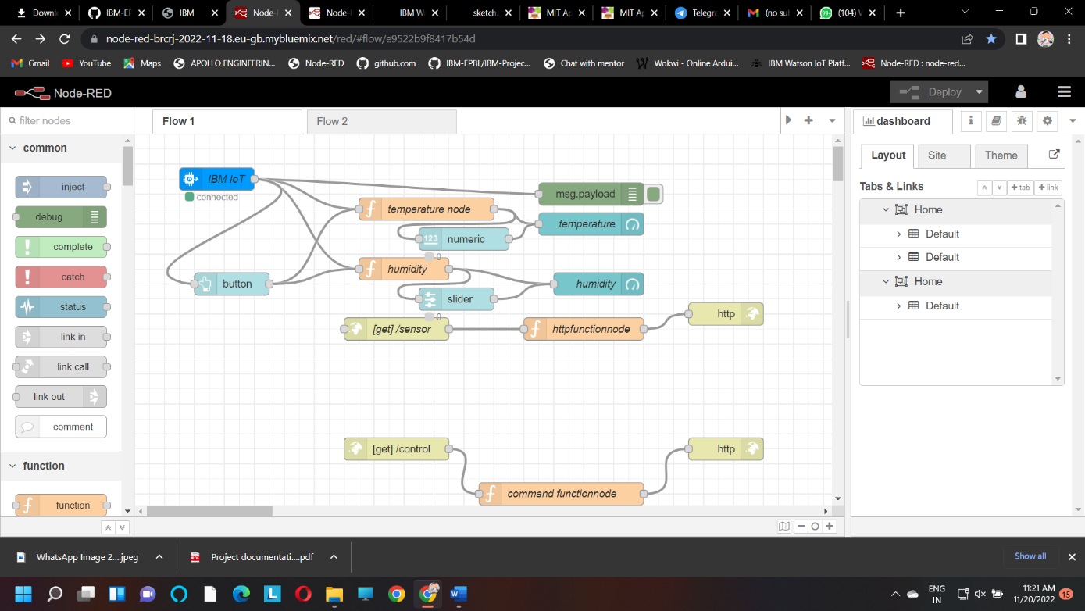

**UI Testing:**

